School News – February 2023

Parents’ Evening
Thank you all for coming along to Parents’ Evenings earlier in January. I do hope you found your conversations helpful as well as celebratory. The feedback I have had from class teachers has been overwhelmingly positive. Thank you for your responses to the Parent View Survey, we will send you the results of this shortly.

Safer Internet Day – Tuesday 7th February
This year’s theme is ‘Want to talk about it? Making space for conversations about life online.’
We want all our pupils to appreciate e-safety issues. Ms Gill has organised resources for us to share with children during our “safer day” next Tuesday in school, but perhaps you could talk further at home? Here is the link to the Parents Guidance page from the UK Safer Internet Centre. This includes Top Tips for Parents and a file of family activities.
https://saferinternet.org.uk/safer-internet-day/safer-internet-day-2023/parents-and-carers
In light of the recent news about the rise in online child sexual exploitation and the parliamentary debate around the Online Safety Bill today, it is absolutely vital for you as parents to access these valuable support pages. You need to ‘learn the dance before the music starts.’

Ukraine Clothing Appeal
We are collecting preloved warm coats, hats, scarves, gloves and cuddly toys in good condition for families in Ukraine. They will be transported by lorry to the Polish border with Ukraine. Here, about 20% of donations are used to help a Ukrainian refugee camp whilst the remainder is taken by trusted sources to be distributed in Ukraine itself.
This work is done in collaboration with Sedbergh School and ‘Siobhan’s Trust’ who take pizza wagons to Ukraine and raise morale delivering pizza to hungry people. It would be wonderful if you could help.
Children’s and adult’s outerwear are very welcome. If you want to read more about this work here is a link to an article on it.
https://www.sedberghschool.org/prep-news/from-kirkby-lonsdale-to-the-ukrainian-border
Thank you so much in anticipation.

Sports News
Inter-house Football - On Thursday 9th March pupils in Y1-6 will take part in an inter-house football competition. All pupils will need an outdoor PE kit and suitable trainers.
PE – After half term Mrs Mercer will be doing Gymnastics with Barbondale and Wharfedale on Wednesday afternoons.

NYCC Adult Learning & Skills Service online course ‘Supporting your child with maths year 6 SATs’
NYCC are running a course for parents/carers to help support your child with their Year 6 Maths SATs. The course will be delivered online and is free of charge – it starts on Monday 20th February, 09.30 – 11.30am or Tuesday 21st February 6-8pm with 5 weekly sessions to follow. You can view the course information by scanning the QR code below or visiting;
https://ebsontrackprospect.northyorks.gov.uk/Page/Prospectus_CourseOverview?uio_id=16895

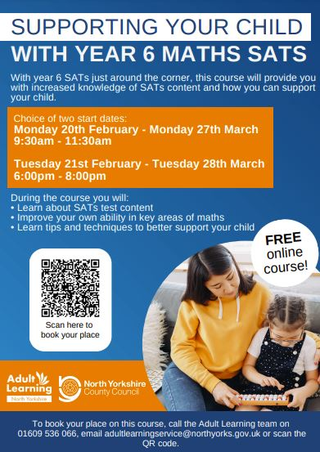

Y6 SATs and Edinburgh Residential Meeting
At 6pm on Wednesday 8th February, Mrs Wilmshurst will talk through our important preparation for Y6 SATs. On a lighter note, details of the Edinburgh Adventure will be shared too. We hope to see many of you coming along. Thank you.

Author Visit
The writer Ross Montgomery will be spending the day with us on Friday 10th February. This exciting visit will be an inspiration for all our budding authors.
Please could you return any advance orders for Ross’s books by Friday, so we can get the order to Limestone Books in Settle. Thank you.

Aladdin at Settle College
Our Y6 pupils will be going to watch the dress rehearsal of Settle College’s production of Aladdin on Wednesday 1st March. As well as being an enjoyable trip out, this is an opportunity for children to feel what it’s like in a secondary school, regardless of their choice of school for September. I am very pleased we have been asked to join the audience!

Village Panto’s
Joining the cast of Hansel and Gretel this year in the chorus at Ingleton panto are Rosie, Connie, Leah, Amelie, Amiyah and, of course, our very own Mrs Joel. Erin is starring in the Bentham panto, The Wizard of Oz. Break a leg, everyone, we will look forward to seeing you all on stage!

World Book Day – Thursday 2nd March
We had such good fun last year dressing up as book characters that we thought we’d do it again! We will send more details after half term, but please save the date in the meantime.
For something new this year, we are planning a second hand book sale, of both children’s and adult’s books.

Cooking Club and Gardening Club
I have enjoyed cooking soup, pizzas, curries and shepherd’s pie with many children from years 4 and 5 at Cooking Club over the past few months. These children have learnt new skills and had great fun. A big thank you must go to Mandy Parker for all her help.
After half term, Gardening Club will begin and that really does mark the start of the new growing season. Details will follow for those keen gardeners who are interested in joining.

Hedge Laying
Bill Hartley has done a fabulous job of laying our hedge. It looks a bit drastic, but will shoot up very quickly once things start to grow. Hedge laying is an art that is both ancient and environmentally friendly, not least because the dense hedges it creates provide a vital habitat for wildlife (small mammals, birds and butterflies) that no other option can rival. A properly laid hedge needs no additional fencing, and will remain impenetrable year-round. Well done Bill, we are at the forefront of conservation at Ingleton Primary School.

School Meal Prices
After February half term we are having to increase the price of school dinners. We were informed of this increase just before Christmas by Facilities Management, our school meals provider. Due to this lack of notice from them, school has been making up the difference in price for this half term, but we cannot sustain this additional cost any longer. From Monday 20th February a meal will cost £3 per day. We apologise for this, but it is unavoidable. I do hope your children will be able to continue to have school meals. Our team in the kitchen do a fabulous job and cater for every child’s needs daily.

Nut Allergy
Just a reminder that we are a ‘nut free school’ due to pupils with peanut allergies. Please would you ensure that packed lunches and snacks do not contain nuts. Thank you for your understanding.

Head lice
We have had a few cases of head lice across a number of classes. I’m sure you do already, but please could you check for these little critters regularly and remind those with long hair that their bobble needs to be in their hair not round their wrist in school. Thank you.

Medication in school
If there is a need for us to administer prescription medication we will request that you complete a parental agreement form. Children must not bring any medicines to school.

Half term holiday
School will be closed the week of 13th February. We will re-open on Monday 20th February.

J Colledge
February 2023

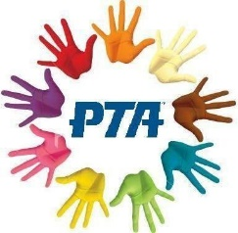
https://www.facebook.com/IngletonPrimaryPTA
pta@ingleton-pri.n-yorks.sch.uk

Upcoming Events!

Valentine’s Disco

The Valentine’s Disco is back! There will be fun and games, sweeties and fairy cakes to buy, free drinks, neon face painting, and of course lots of dancing! Please see the poster above for the timings for the two discos and the 50p entry charge, the disco will be in the hall.
Reception parents need to stay at school whilst their children are at the disco.
KS1 and KS2 parents can drop off and return after an hour.

Any questions please get in touch with us via email or Facebook messenger. Thank you!

