October News 2022

Head Boy and Head Girl
We are very pleased to announce that James and Maia are Ingleton Primary School’s Head Boy and Head Girl. They will represent the school many times this year and we are very proud of them. Their first duty last week was to keep the scores at our inter-house Mini Olympics and they did this brilliantly, although James did describe the experience as ‘very stressful!’

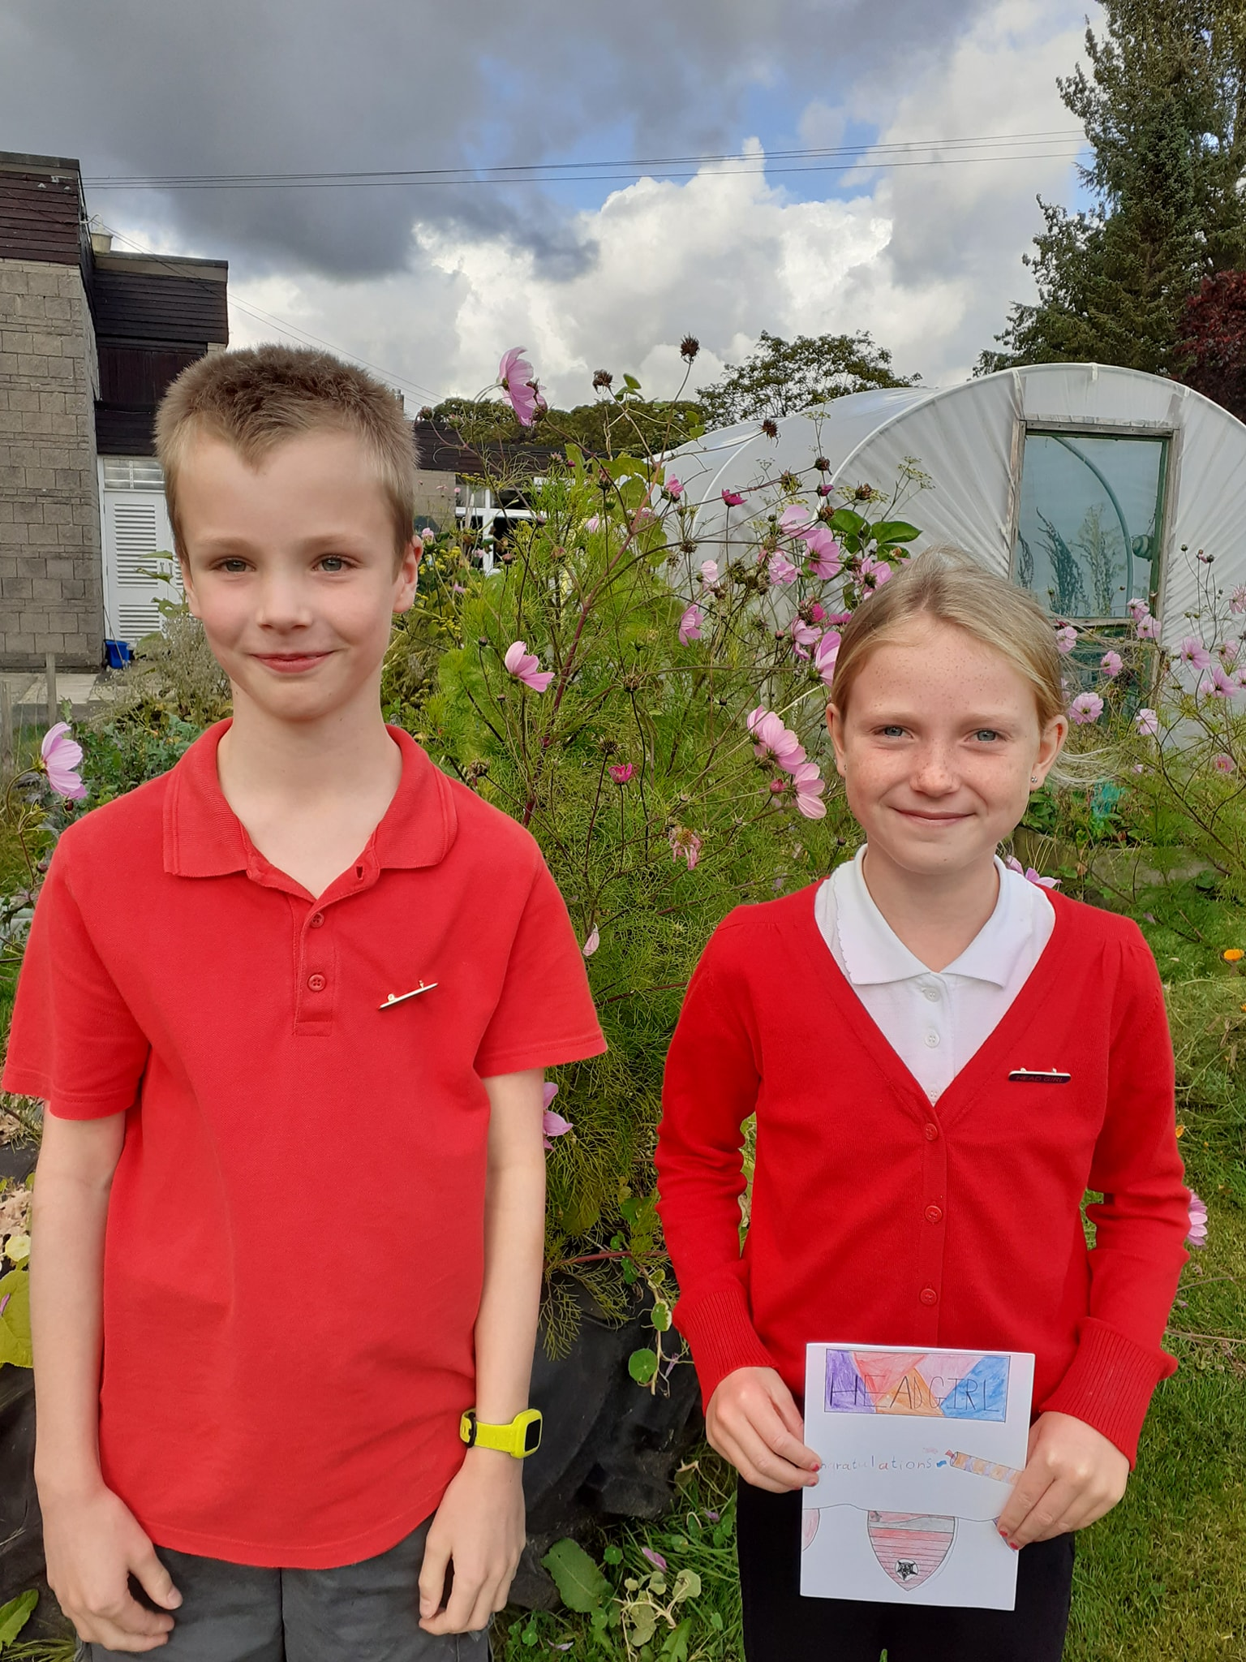

Johnny Walker Rugby
The storm last Friday afternoon meant this rugby tournament at Settle had to be postponed. Children selected for the teams from Y3 to 6 will now take part on Friday 13th October. Miss Middleton has all the details. Fingers crossed for more settled weather that day!

Safety Talks
Craig Lyons, our Public Safety Officer for North Yorkshire Fire and Rescue Service will be visiting school on November 4th. He is going to talk to the children about fire safety before Bonfire night. Good timing.

Nut Free School
To keep all children safe, we continue to be a nut free school. Please would you ensure that packed lunches and morning snacks do not contain nuts. Morning snacks should be fruit or bread based. Thank you.

Starting school in September 2023
Parents of children who are in Nursery will need to complete the online application form to secure a school place next September. The opening date for applications is 12th October 2022. Further information will be emailed to Nursery parents shortly.

Transferring to secondary school in September 2023
Online applications need to be submitted by October 31st for your choice of secondary school for your child. This can be done via the link https://www.northyorks.gov.uk/school-admissions

Attendance
I hope you found the attendance brochure informative. Improving attendance is a school priority this year and our attendance rate currently stands at 96%.
Please inform the office of any absences due to sickness. If we have not heard anything by 9.30am we will ring home. If your child is sick or has diarrhoea, please keep them at home for 48 hours. Also, if your child attends a medical and or appointments during school hours, please would you ensure they are in school for the rest of the day if time permits. Thank you.

Countryfile Ramble
On Thursday 6th October our children in Early Years Foundation Stage will be taking part in the ‘Countryfile Ramble.’ We have planned a route around the village and would like to invite parents/grandparents/carers to join us. Refreshments will be served when we return to school at around 10.30am with all donations going to BBC Children in Need.

Trainee Teachers
We are enjoying having Miss Moore and Miss Connell working as part of the Early Years team this term. They are in school on Wednesdays and Thursdays until half term and then will enjoy a six-week teaching placement, the first of their Post Graduate Certificate in Education course. Working alongside the University of Cumbria by developing trainee teachers is an important part of our work as a school. We need great people joining the profession.

Staff Roles and Responsibilities
Staff curriculum responsibilities remain the same this year, but for your information they are:
Mrs J Colledge - Head Teacher, Designated Safeguarding Lead (DSL), Subject leader for the Arts, RE and Educational Visits Co-ordinator
Mrs R Clements - Co-Deputy Headteacher & Subject Leader for English & Assessment, Deputy DSL
Miss J Middleton - Co-Deputy Headteacher & Subject Leader for Maths, PE & Assessment, Deputy DSL
Ms J Gill - Subject Leader for Computing & Science
Mr M Forde - Subject Leader for PSHE, RSE & History
Mrs. J Pickard - Subject Leader for Geography
Mrs A Jackson - Subject Leader for Maths & MFL
Mrs H Burnett – Special Educational Needs Co-ordinator (SENCO)
Mrs V Bromley - Subject leader for DT
If you have a specific question about a curriculum area, subject leaders would be happy to share their expertise. All of our school policies and procedures are available to read on the school website. https://ingleton-pri.n-yorks.sch.uk/

NSPCC Speak Out. Stay Safe.
Today and tomorrow we will deliver online assemblies as part of the NSPCC’s Speak Out Stay Safe programme. Next Monday pupils in Y5 and Y6 will take part in workshops run by NSPCC volunteers. Ask your children about the important messages passed on during the assemblies.

Macmillan Coffee Afternoon
On Friday 21st October we will be holding a Macmillan Coffee Afternoon. We haven’t had one of these community events since 2019. Our Y6 children will run the event and we would appreciate donations of baking please. More details will be coming from the children shortly.

Anti-social behaviour in the school grounds
For a long time now we have been tolerating litter left behind in the school grounds at weekends and during the evening, especially in the ‘bandstand’ or outdoor shelter. Last weekend some empty gas canisters (nitrous oxide) and balloons were discarded by trespassers. This is greatly concerning. As a result of this I have been in touch with the community police and local secondary schools.
The school grounds are not public spaces. The three gates are locked at night and over the weekend and the fields are only available to be used by prior arrangement with the school.

School Photos
Jane from Tempest Photography will be coming to take individual and siblings photos on Monday 21st November. Please come at 8.30am if you have pre-school siblings not attending our Nursery to join the family photo.

Flu Immunisation
Parental consent for the flu immunisations on November 15th is due by October 31st. This consent is done via the link https://www.hdftsais.co.uk/Forms/Flu and entering school code HD121445.

Cauliflower Card Designs
Our most important news is that the Design Your Own Christmas Card forms will be coming home with your children soon! The deadline for designs this year is Monday 7th November. For inspiration visit www.cauliflowercards.co.uk . This is a great way to raise money for our school! Any questions, do get in touch.

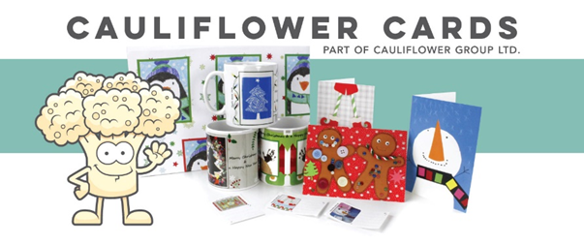

Half-term holiday
We will break up for October half term on Friday 21st October. School reopens on Monday 31st October.

Jo Colledge
October 2022

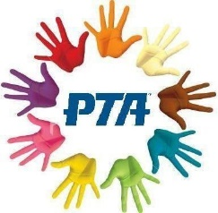
https://www.facebook.com/IngletonPrimaryPTA
pta@ingleton-pri.n-yorks.sch.uk
Welcome
Welcome to Ingleton Primary School PTA news. We are a friendly small team always on the look out for new members to help in different ways… helping out at events, being a class rep, planning events, arranging uniform orders, selling raffle tickets etc. We meet once a half term, or as required, and are always keen to have new members. If you are interested please contact us on our email or message us via our PTA Facebook page.
AGM-all invited
You are all invited to our AGM on Monday 10th October at 7pm at School. We will review our fundraising efforts over the past year, elect committee members and look forward to the year ahead. Refreshments will be provided. There is no commitment to join the team if you’d just like to come and hear more! If you are able to attend please email pta@ingleton-pri.n-yorks.sch.uk.
Upcoming Events
PTA events are advertised through school email, school text, newsletters, and on our PTA Facebook page. If you are on Facebook why not follow us to be kept up to date.
Fundraising Should you wish to raise further funds you can help by signing up to www.easyfundraising.co.uk and www.smile.amazon.co.uk. Whenever you make a purchase on Amazon or at a whole host of stores through Easyfundraising, a small percentage of the sale will be donated to school. Thank you.
Any Questions?
Please get in touch! If you have any questions or any fantastic fundraising ideas we would love to hear from you. Drop us an email or Facebook message. Thank you.

