November 2022 Newsletter

Welcome back
I hope everyone had a good half term break and batteries are fully recharged ready for the term ahead.

School Values
This half term we will be exploring TRUST during assemblies. We have begun this week by discussing how we put trust in others.

Macmillan Coffee Afternoon
Thank you to everyone who supported our Y6 children with their Macmillan Coffee Afternoon before half term. They ran a tremendous event that was so well attended by many generations from our community. A fantastic £903.12 was raised for Macmillan. Overwhelming, thank you so much.

Statutory Assessments 2022/23
Like last year, all statutory assessments for your children will take place this academic year and they will be assessed on their end of year expectations. Already the Reception Baseline Assessments have been submitted. The week beginning 8th May 2023 is when Y6 children will sit their SATs. The Y2 SATs will also take place in May. In June the Y4 Multiplication Tables Check will take place for the second year running. Children will be expected to know their tables up to 12x12. Also in June Y1 pupils will have their Phonics Screening Check.
Please rest assured that class teachers will be passing on detailed information about all of these assessments in due course.
School’s performance data will be published nationally next year. Last year’s performance data is available to view on our website.

Poppies
Unfortunately our local poppy representative is no longer distributing poppies and we won’t have any in school to buy. We hope you can still support the Royal British Legion Appeal by buying poppies from another shop or representative.

Co-op Community Fund
We have just received our final payment from the Co-op for £2,688.91 and the children and staff would like to thank the Co-op and the customers who supported us to raise this fantastic amount of money. We are very fortunate to have been chosen once again to receive the Co-op Community Fund.
If you are a Co-op member you can log onto your account and select us as your chosen cause. The link to your Cause Profile Page is https://membership.coop.co.uk/causes/71524
If you are not a member it is worth joining as there are many benefits for both shoppers and local causes, visit coop.co.uk/membership to sign up. We will be using the donations to continue developing areas for outdoor learning.

A request from Early Years
We were wondering if anybody at home has any toys/equipment you or your children have outgrown and if you could kindly donate to our Early Years classrooms. Our toys and equipment are so well used and loved but their time does eventually come to an end so we do appreciate anything you can donate. We are particularly on the lookout for items to enhance our home corners - Kitchen equipment (real pots and pans, spoons, spatulas, teapots etc. would be wonderful!), pretend irons/ironing boards, hoovers, tea towels, small chairs and tables, dolls and prams/cots, tills, false flowers/plants.
We always appreciate your cardboard recycling too - tubes and small boxes. Please drop them off with Mrs Burnett if you ever have a bag full. We appreciate it any time!

Nursery Stay and Play sessions
Our new starters for January are invited to come and have a play in Nursery on Thursday 1st December and Wednesday 7th December between 1.30pm and 2.30pm. This is a lovely opportunity to spend some time in this new environment before joining the class for the spring term.

Christmas Shoe Boxes
We sent home leaflets before the holidays on behalf of Boxes of Hope (Cumbria). If you would like to participate, please send boxes into school before 9.30am on Friday 18th November. Thank you.

Winter Cooking Club
This club for Y4/5/6 children begins next Thursday after school at the I Centre. We will be making vegetable soup and cheese scones during the first week. Further details have been sent to the children keen to join the club.

Stone Age Days
KS2 children will be going back in time to the Stone Age in November. Visitors from Woodmatters company will be bringing artefacts and organising a day of fun Stone Age activities. Children will have their day on either 16th or 17th of November.

Theatre Trip
Children from Year 1 to Year 6 are going to see Robin Hood at the Dukes Playhouse in Lancaster on 2nd December. Oh no they're not! Oh yes they are! PTA and school fund are subsidising the cost of the tickets so we will be asking for a voluntary contribution of £6.00 per child. Transport to The Dukes, Lancaster is being paid through the grant from our local councillor, David Ireton. We secured this funding for transport to enable more cultural visits for our children. We will add the visit to Parentpay soon.

BBC Children in Need
The Countryfile Ramble enjoyed by our EYFS children and their parents raised over £100. Thank you all for your kind donations to this worthy cause. This year we have decided not to sell Pudsey merchandise or hold an additional fundraiser for Children in Need.

Anti-Bullying Song Workshop
Our children in key stages 1 and 2 will enjoy an afternoon of song on Friday 18th November, devised and delivered by Brian Beresford, musical educator and former Primary headteacher in Lancashire and North Yorkshire, who lives in Skipton.
Brian Beresford aims to spread effective anti-bullying messages through the medium of song. LET ME BE ME is already sung in many schools across the UK and Brian is offering to run workshops, teaching the anti-bullying messages that are introduced in the song. With its catchy, easy to remember chorus, the tune and words of this unique song pop into the minds of those who have sung it, helping the message to “stick”. Although the song is positive and up-beat it also has sensitive, thought-provoking sections that can stimulate discussion, questions and appropriate activities and actions.

Sports News

PE
This term Sam from SDA Academy is doing football sessions with Barbondale and Wensleydale. Becky Mercer is doing Netball with Swaledale and Wharfedale. Kingsdale and Dentdale will have their sessions next term.

Clubs
Get in touch with sam@sdasportsacademy.co.uk if you would like a place on either of his after-school clubs. Monday is football 3:30-4:30 and Thursday is multi-sports 3:30-4:30.

New this term! Mrs Mercer will be doing a badminton club on Wednesday lunchtimes. This will be for different age groups on a rotation, Mrs Mercer has informed groups today.

Miss Middleton will be doing a girl's football club on Monday lunchtimes, in the hope of entering a girl's football competition in December.

Competitions
On Thursday 10th November 6 pupils are going to the North Yorkshire Cross-country Final at Giggleswick School. They have taken part in two qualifying rounds to get here and we are super proud of them. Good luck James, Daniel, George, Lucy, Flo and Lottie!

Y5 lantern making
On Friday 25th November Y5s will continue our school tradition of making willow and paper lanterns in preparation for the village Christmas event the following day. We look forward to welcoming Kate Rowe.

School Photographs
These are taking place on Monday 21st November. The photographer will be available from 8.30am to take family groups with pre-school age children (not Nursery). Siblings in school will be photographed together during the morning.

Flu Vaccinations
The School Age Immunisation Service will be visiting your child’s school on 15.11.22 to deliver the nasal spray flu vaccine.
Please ensure you have completed the online consent form for your child to receive this vaccine.
Your child will not receive this vaccine without a valid consent form.
Your consent portal will close on 8.11.22 Access the consent link here: https://www.hdftsais.co.uk/
School code: HD121445 If you have any problems with completing the online consent, please contact the Immunisations Consent Team on 03000 032554. For more information on the flu nasal spray vaccine please visit: https://www.nhs.uk/conditions/vaccinations/child-flu-vaccine/

Infant Free School Meals
This is a great initiative for families but it actually has a detrimental effect on our income since we used to gain Pupil Premium funds for anyone who has registered for Free School Meals. We would appreciate anyone who thinks they may be entitled to speak to us, in confidence. Benefits to children in receipt of Pupil Premium include free educational visits and this carries on for six years, even if the family are no longer eligible. https://fisportal.northyorks.gov.uk/Synergy/fsm_prereq.aspx

Dinner Money
We currently have a number of outstanding meal payments from last term. Please pay promptly via ParentPay if you wish your child to continue to have school meals. We would be very grateful if meal payments could be paid in advance, either at the beginning of each term or each week. Our meal service is self-funding so to ensure we are able to continue to offer our high level of service we rely on payments being kept up to date. Thank you to everyone who pays in advance.

Starting School
If you have a child who was born between 1st September 2018 and 31st August 2019 they are due to start school in September 2023 and you need to apply for a place before January 2023. For all school admissions ring 01609 533679 or use the North Yorkshire County Council website www.northyorks.gov.uk/admissions.

Outdoor Clothing
Please remind your child to come to school prepared for cold weather with coats, hats and gloves, since outdoor learning and play times need to be comfortable and enjoyable. They also require outdoor kit and footwear for PE lessons (tracksuit bottoms, warm top over t-shirt and trainers)

EYFS Nativity
Save the date! We look forward to inviting the families of our youngest children to watch their Christmas Nativity on Thursday 8th December at 9.30am. Further details nearer the time.

Christmas Dinner and Party Food
We like the children who normally enjoy packed lunches to have the opportunity to share our special Christmas Dinner which is on Wednesday 7th December and the party food (including Nursery) planned for Friday 16th. All children are invited to have dinner and/or party food so if your child usually has a packed lunch and would like to join us for either or both of the days, please order at the office before 21st November, informing us of any special dietary requirements. (Meals cost £2.78 for main school and £1.90 for nursery). We are unable to accept any requests after this date. All pupils in Reception, Y1 and Y2 will be entitled to free meals as usual.

Cauliflower card orders
If you would like to place an order for the Cauliflower cards, please bring in your designs by Monday 7th November and place your order online beforehand.

Local Events

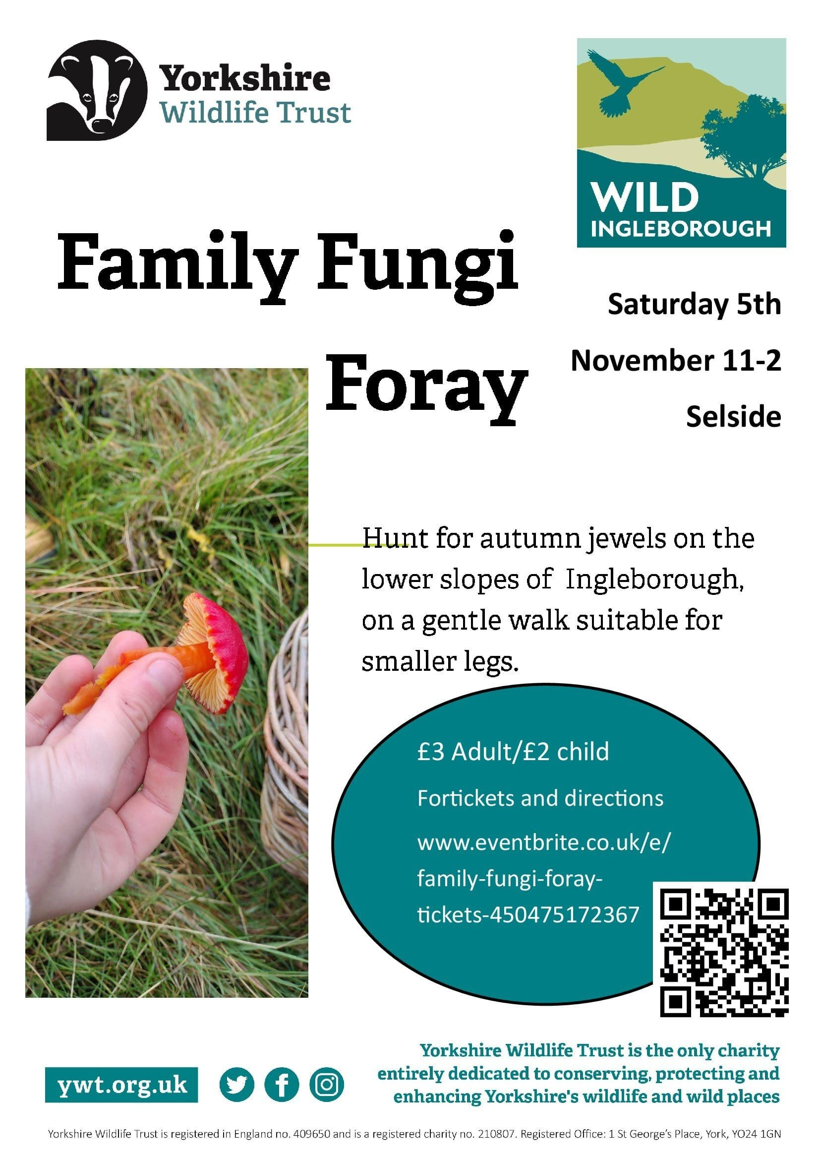

Parent Support Groups
This month’s support group topic from the Bradford and Craven NHS Mental Health Support Team is ‘Navigating Mental Health Services in Bradford and Craven’ more details are below.

