School News – February 2022
Parents’ Evening
Thank you all for joining the Google Meets last week to talk with our class teachers about your children. I do hope you found your conversations helpful as well as celebratory. The feedback I have had from class teachers has been overwhelmingly positive. As a follow up, I would be most grateful if you would complete our Parent View Survey, following the link:
https://forms.gle/6tV1pHME3ke3cmvD6
If you could complete the survey by Friday 11th February, we will be able to compile some feedback before half term. Thank you.

Covid disruption
Since the beginning of this term, we have had 4 staff and 23 children test positive for Covid. They have all been absent from school for at least 5 days. This has caused inevitable disruption to children’s learning and the continuity of teaching. Teachers have provided remote learning for those children well enough to complete it, but there are gaps to fill upon their return. For teachers, this is proving to be a real juggling act and their workload has increased significantly recently. Everyone is trying their very best to make each child’s return to school as seamless as possible. I sincerely hope these difficult times will soon pass and we can move on to planning activities and events that no child will miss.

Dales Reading Challenge
Wensleydale are the proud custodians of the Reading Dog this fortnight. Well done to all the avid readers in the class and to their families of course. The children nominated for outstanding reader award were: Bailey, Callam, Jack, Ted, Jemima and Oskar. Callam and Oskar won the draw and are looking after the two puppies. Good effort and well done to all of you.

Ancient Egypt Workshop
Last Monday we welcomed to school a company called ‘Imagining History.’ All children in key stage two enjoyed a half-day session of drama and storytelling and were transported back in time to Ancient Egypt.

Ingleborough Walk
Today Y6 pupils are enjoying walking up Ingleborough with Olly Roberts. ADD at 3.30pm!!

SPORTS NEWS
Gymnastics – This term we welcomed back Mrs Mercer after her maternity leave. She has been teaching Gymnastics to Barbondale and Wensleydale this term, and will teach each class over the next few months.
Badminton Club – Year 6 have been enjoying a badminton club on Wednesday lunchtimes, and will continue to do so this month. After half-term Year 5 pupils will have the opportunity.
Craven School Games – This year the way that school sports competitions are organised has significantly changed. In previous years we have had a school games sports organiser for North Craven, who organises all the inter-school competitions. Unfortunately, this has changed for North Craven Primary Schools as the SGOs are focussing on Years 7 and 8. This means that we will be arranging our own competitions. The calendar of competitions is currently being planned between us here at Ingleton and other local Primary Schools, so it won’t be too long before we welcome some inter-school events. Exciting times ahead!
Marathon Challenge – Some of you may remember a few years ago we did a school marathon challenge. We are opening this up again after half-term. The challenge is open to pupils across the school with varying distance targets, 5K, 10K, half-marathon and a marathon. This will be done at various times throughout the school day as children are invited to run laps around the school grounds to hit their personal target.
Yorkshire Dales National Park – ‘Learn, Love, Explore’
The Yorkshire Dales National Park’s Education Team have had an education offer for schools across the Park since last year. With the ‘Sustainability and Climate Change Strategy’ due to be published by the Department for Education in April 2022, the YDNP want to support schools to develop and embed their practice around Environmental and Outdoor Learning.
As a school, we hope to take part in many of the activities offered locally as well as joining the Ambassador School Programme. This will involve training, resources, opportunities to take part in the John Muir Award and support in developing the school grounds to enhance our own planned outdoor learning opportunities.
I look forward to keeping you updated with this exciting project over the coming months.

Birdsong Project
Next Monday 7th February, pupils in Swaledale will be involved in a ‘Birdsong’ workshop. It sounds like a very interesting and unique opportunity not to be missed.
The WWF are sponsoring a project to record the people, landscape and natural history of the Ingleborough dale. Matthew Somerville and Anna Greenwood are filming and recording stories and events across the dale over the next 3 to 4 months. As part of this, they are holding two workshops run by Planet Birdsong (https://www.planetbirdsong.org/birdsong-studio.html

Safer Internet Day – Tuesday 8th February
This year’s theme is 'All fun and games? Exploring respect and relationships online'. From gaming and chat, to streaming and video, young people are shaping the interactive entertainment spaces they are a part of.
We want all our pupils to appreciate e-safety issues. Ms Gill has organised resources for us to share with children during our “safer day” next Tuesday in school, but perhaps you could talk further at home? Here is the link to the Parents Guidance page from the UK Safer Internet Centre. This includes Top Tips for Parents and a file of family activities.
https://saferinternet.org.uk/safer-internet-day/safer-internet-day-2022/advice-for-parents-and-carers

NYCC Adult Learning & Skills Service online course ‘Supporting your child with maths year 6 SATs’
NYCC are running a course for parents/carers to help support your child with their Year 6 Maths SATs. The course will be delivered online via Zoom and is free of charge – it starts on Monday 28th February, 09.30 – 11.30, with 5 weekly sessions to follow.

You can view the course information by following this link: ontrack: prospect - Course Details (northyorks.gov.uk)

VR Workshop
On the 14th of February, the whole school will be involved in a Virtual Reality Space Workshop by Education Group, giving every child the chance to become an astronaut! This is a truly exciting event, and we can't wait to take part.

World Book Day – Thursday 3rd March
Mrs Clements will be informing you about World Book day – plans are afoot!

School Book Fair
Books to browse and buy will be arriving on Monday 28th February for one week. You are welcome to look either before or after school and can spend your World Book day tokens. We appreciate your purchases since it boosts our school resources too.

Cooking Club and Gardening Club
I have enjoyed cooking soup, pizzas, curries and lasagne with children from years 5 and 6 at Cooking Club over the past few months. These children have learnt new skills and had great fun. A big thank you must go to Mandy Parker for all her help.
After half term, Gardening Club will begin and that really does mark the start of the new growing season. Details will follow for those keen gardeners who are interested in joining.

Lunches
Please remember that dinner money should be paid in advance, either at the start of the half-term or at the beginning of each week. Pupils are only charged for the meals they have so credit for any absences remains in your meals account on ParentPay. Please ensure any debit balances are cleared by half-term. Thank you.

Medication in school
If there is a need for us to administer prescription medication we will request that you complete a parental agreement form. Children must not bring any medicines to school.

Half term holiday
School will be closed the week of 21st February. We will re-open on Monday 28th February.

J Colledge
February 2022

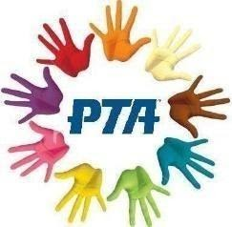
https://www.facebook.com/IngletonPrimaryPTA
pta@ingleton-pri.n-yorks.sch.uk
Nursery Shed
The PTA were delighted to buy this smashing new shed for Nursery for all their outdoor equipment.
Book Update
Another instalment of books from PTA funds has arrived!
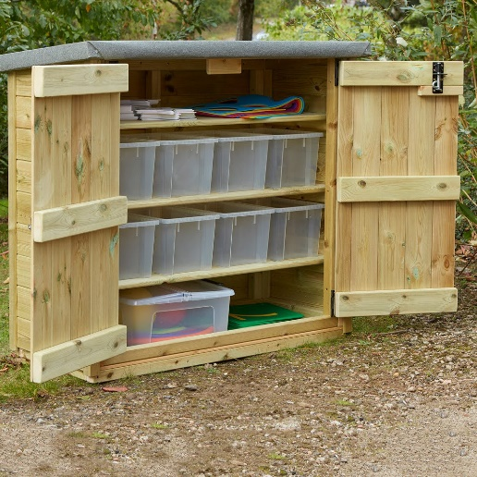
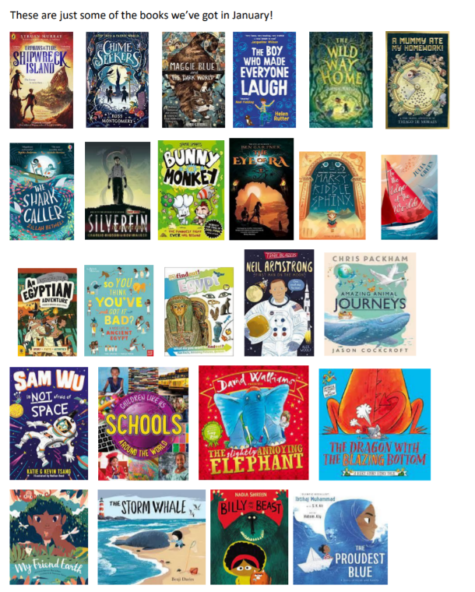

Easy Everyday Fundraising at no extra cost with Amazon Smile
If you use Amazon, with each purchase, a donation could be coming to the PTA at no extra cost to you. Here’s how it works…
Amazon donates 0.5% of the net purchase price (excluding VAT, returns and shipping fees) of eligible purchases to the charitable organisation of your choice.
- Go to www.smile.amazon.co.uk
- Sign in using your existing Amazon account details
- Choose to support Ingleton Primary Parent Teacher Association
- It also works in the Amazon App. Once you’ve signed up as a member on www.smile.amazon.co.uk go to Setting on the app and follow the instructions to turn on AmazonSmile on your phone.

