End of Spring Term News
April 2022

Brathay Hall Adventures
Year 5 children had a truly memorable time away last week with Mr Forde, Mrs Mattinson and Mrs Colledge - we are really grateful for everyone’s time and hard work with the visit. There will be a special assembly when parents and carers can see the photos and hear the stories after the Easter holidays.

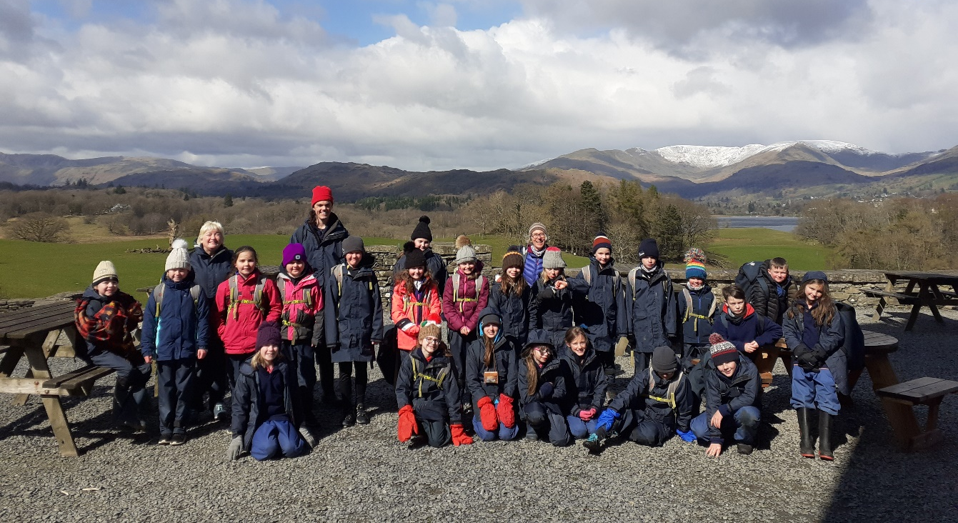

Summer Term Assessments
After Easter we see the return of primary statutory assessments for the first time in 3 years. Y6 SATs are timetabled to take place during the week beginning 9th May. Y2 SATs will also be carried out during May. The Y1 Phonics Screening and Y4 Multiplication Tables Check will be carried out over a period in June. The EYFS Profile will also be completed in June.

Keeping Children Safe Online
Our school shares a purpose with parents and carers to keep children safe from harm and to have their welfare promoted. We take the issue of online safety most seriously and ensure that your children are safe online while in school. For more information about how you can do everything to ensure they are safe online while at home, follow these links to helpful websites:
https://www.thinkuknow.co.uk/parents/
http://www.internetmatters.org/
https://parentzone.org.uk/
https://www.childnet.com/
http://www.parentsprotect.co.uk/

Latest Covid Advice from DfE
As from last Friday 1st April, the guidance for people testing positive for Covid has changed. It is now recommended that adults stay away from the workplace for 5 days and children have only 3 days off school. There is no longer a requirement to have 2 negative lateral flow tests 24 hours apart from day 5 onwards. We are now entering the ‘living with Covid era’ and are being told to treat the illness like any other respiratory infection. Many people won’t even know they have Covid now free testing is unavailable.

Covid vaccines for 5-11 year olds
Please visit the link below for further guidance on vaccines for 5-11 year olds. They will be available over the Easter holidays and further dates after then.
UKHSA_12308_COVID-19_Guide_for_parents_of_5-11years_A5_8pp_leaflet GW20211039 09_WEB (1).pdf

Outdoor Adventurous Activities
We have more opportunities planned for the summer term to enhance our outdoor education offer. In May Y4 will have a day caving and climbing. In June Y5 will be climbing Ingleborough. In July Y6 will go ghyll scrambling at Barbon Beck. All of these fabulous experiences will be led by Olly Roberts and his team and supported by our staff.

Kendal Ski Slope Primary Race
We have entered a team of promising young skiers in the Kendal Ski Slope event to be held on April 28th at 4pm. We look forward to reporting their success in the May newsletter.

Science Week
This year's British Science week was celebrated nationally, back in March. The theme was "Growth". Like many schools we have decided to wait for better weather and celebrate all things Science 16th-20th May. This is rescheduled from our first week back after the Easter holidays and we hope, by May, this cold snap will have passed, and we can thoroughly enjoy the outdoor activities planned.

Class Photos
Jane from Tempest Photography is coming in to do class photos (fingers crossed outside) on the 26th April.

Ukraine Appeal
We raised £746.47 for the Ukraine DEC appeal. Thank you so much for your generosity.

Red Nose Day
We sold an incredible 190 red noses and raised £285.50 for Comic Relief. Thank you!

St Mary’s Church Easter Crafts
On Monday 11th April from 2-4pm there will be an Easter craft session at St Mary’s. It is free to attend to all ages and food will be provided. No need to book, just turn up.

Changes to Children and Young People Services in North Yorkshire
In North Yorkshire and York a range of national and locally-funded support for children and young people is now embedded, including:-
The Go-To Website – the home of wellbeing and mental health in North Yorkshire. The website helps young people find the right help and support to stay well, whatever is happening in their life. It also has advice and links for parents and carers on a range of areas.

Seed Cards
Leea Heald has designed a beautiful Ingleton Primary greetings card, printed on seed paper. It will be on sale shortly. All proceeds will go towards School Fund. What a lovely gesture from Leea.

Sports News
﻿ Judo - Last month pupils from Reception to Year 6 all enjoyed a Judo taster session at the Dojo at Ingleton i-centre. Danny was so impressed with our pupils and everyone enjoyed the activities. If you would like more information about Craven Judo Academy please email Danny.
Marathon Challenge - Ingleton Primary School Marathon Challenge is still going strong. Lots of pupils have already completed a marathon, and are now on their second or even third! It is fantastic to see everyone running around the school grounds and encouraging each other along the way.

Y3-6 Tournament - In March, we hosted a football tournament for KS2. We had 4 teams who played each other, and teams from SDA Sports Academy. It was a great event, fantastic to see so many children involved.
Girls Football Day - On the 9th March we took part in the ‘Biggest Ever Girls Football Session 2022’ which saw almost all of our KS2 girls enjoying some drills, games and matches at lunchtime.
Y5-6 Football Festival - This week we took 2 teams of Y5&6 pupils to Settle College for the North Craven Football Festival. The afternoon involved lots of matches against other local primary schools. Thank you to Settle College for hosting this event.
It was wonderful to see some familiar faces amongst the Y7&8 Sports Leaders.
PE - This term classes have enjoyed Outdoor Adventurous Activities in their PE sessions. This has included activities such as team challenges, orienteering and Forest school fun.
Next term, pupils in Y2-6 will experience some cricket sessions with local cricketer John Hughes.
Dentdale and Kingsdale will enjoy the expertise of Mrs Mercer for their Gymnastics sessions.

PTA Easter Eggstravaganza
Due to a poor weather forecast for Thursday, our Easter Raffle and Craft Display will now take place on Friday 8th at 3.30pm. Unfortunately the Easter Trail and refreshments will be postponed. Entries for the Craft Competition to be brought to school on Thursday or Friday. Raffle tickets can be bought Thursday and Friday mornings and after school.
The PTA look forward to seeing everyone on Friday!

Finally, over to the children:

Running in the Kendal Winter League – by Lucy
We have all taken part in every sort of weather in the Kendal Winter League to represent Settle Harriers. The races have been all over the Kendal and Yorkshire area. They have all been pretty steep and we were running against other junior running clubs and ourselves. This is why we love them so much- you don’t have to think it as a race you can just think that it is just for a bit of fun. We get to know some of the other runners from different running teams and challenge ourselves to try and do better every week. It is also fun cheering on other Settle Harriers from different age groups and mums and dads. There has been a lot of success in each race and in the league over the whole winter. With Lucy finishing 3rd, Amelie, Edie and Edie all in the top 20 in the girls under 11s. James and Stanley in the top ten in the under 11 boys and Andrew being the youngest runner in his first race last week. Ewan finished top ten and Ethan finished top 15 in the races he did in the under 13 boys.

Year 5 Residential to Brathay – by Avena-Lea
Brathay was amazing. We did loads of fun things. My favourite thing was ghyll scrambling, even though we got wet head to toe. It was really fun because I have never done it before. It was the best three days of my life. I jumped in at the end of the ghyll scrambling. We would of never have done it without Chris and Rod. Thank you Teachers.

By Maia
On Wednesday 30th March 2022 we went away on a residential trip to Brathay Hall in Ambleside. When we got there we had a site tour. After that we went ghyll scrambling. The water was very cold, but we still had a great time. The next day we got our waterproofs on and went to the canoe shed. We canoed across Windermere, the water was very choppy and we got splashed. We then walked to Wray castle and had our lunch. We then walked back to Brathay using a map. Once we got back I had a warm shower. The next day we went down to the climbing wall. It was really high and we had to put a harness on. It was quite difficult, but I really enjoyed it. After that we did some bouldering, which is climbing sideways. In the afternoon we made a fire, toasted marshmallows and roasted popcorn. After the fire we went to the tuck shop and bought some sweets. Finally we got our bags and went home on the coach. I really enjoyed my trip to Brathay Hall.

School reopens on Monday 25th April. Have a lovely Easter holiday everyone.

